Domaine Chandon de Briailles
Savigny-lès-Beaune
The beauty of the unknown
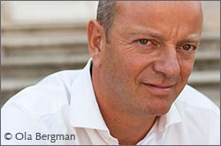
I
t all began with an unknown appellation, with a name nobody knew how to pronounce. Domaine Chandon de Briailles in Savigny-lès-Beaune may have five grand crus on the Corton hill, but it is a premier cru François de Nicolay considers to be their cheval de bataille, their flagship.
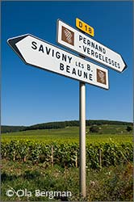– This wine, the Pernand-Vergelesses premier cru Île des Vergelesses, is very representative for our domaine, he says. I think it is this appellation that made our domaine well-known. But when my mother started selling it nobody had heard of Pernand-Vergelesses before. And to make matters worse they couldn’t pronounce it. So commercially it was really bad.
Domaine Chandon de Briailles has been in the family since 1834. Initially there were only the Savigny-lès-Beaune and Pernand-Verglesses vineyards.
– Then my great great grandmother sold 300 hectares of land up in the Hautes-Côtes, land for cereal production. For that she could buy four hectares of Corton. She was quite clever.
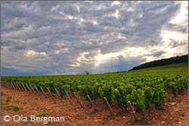At Domaine Chandon de Briailles the Pernand-Vergelesses, Île des Vergelesses comes in both red and white. You will find this premier cru at the southern end of the commune, bordering on Savigny-lès-Beaune. In total it covers 9.61 hectares. A large chunk of this belongs to Domaine Chandon de Briailles – 4.13 hectares. They are also the only ones to make a white Île des Vergelesses – one hectare is planted with chardonnay.
– In the beginning I was not so sure about the chardonnay, says François de Nicolay. But after 10–15 years, when the roots reached deeper, I really understood that it is as good for white as for red.
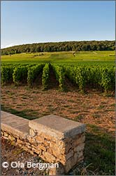Pernand-Vergelesses generally has a slightly cooler climate than the neighbouring villages on the Côte. Île des Vergelesses has one of the better locations, facing east opposite of the Corton hill. It is still a late-ripening parcel. Never a place where they begin harvesting.
– We always start with Corton Maréchaudes, Corton Bressandes or Aloxe-Corton, Les Valozières.
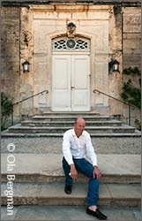– It is said that during the classification in 1937 by the INAO they considered classifying Île des Vergelesses as grand cru. In the end they did not. And they were right, because it is a cooler climate compared with Corton. Some vintages are not warm enough to produce big wines. But in a good year Île des Vergelesses can be nearly as good as a grand cru. And you can keep it as long as a Corton.
– The soil in Île des Vergelesses has a very good balance between clay and limestone. The wine is built on tannins, much more so than the Savigny-lès-Beaune wines. In cooler vintages it can be more rustic and harder than a Corton.
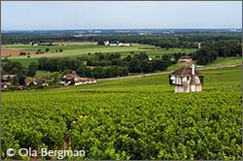Domaine Chandon de Briailles produces five different Cortons – Corton Maréchaudes, Corton Bressandes, Corton Clos du Roi, Corton Blanc and Charlemagne. Three red and two white. The fact that Corton is the least expensive grand cru on the Côte d’Or has earned it a reputation as being undervalued.
– Yes, says François de Nicolay, I agree with that. At least for most Cortons. It’s a very large appellation. 110 hectares for red and more than 70 hectares for white. Some parts are not located well enough to be called grand cru. Then again, this is the only red grand cru on the Côte de Beaune, so you don’t have anything to compare with. But I think things will change now that Domaine de la Romanée-Conti, Domaine Méo-Camuzet and Domaine de Montille have moved in on the Corton hill. Well-known domaines that make very good wines.
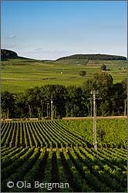Corton Maréchaudes is at the bottom of the hill, below Corton Bressandes and just above the village of Ladoix-Serrigny. François de Nicolay describes it as very silky, feminine wine. It is an expressive wine with very soft tannins which can be enjoyed young.
– Bressandes is mid-slope. The soil is heavy, a lot of clay. It is well-balanced, with lots of limestone. It depends on where in Bressandes you are, but generally it is fifty-fifty clay and limestone.
– Clos du Roi is higher up on the slope and our parcel is at the top, at 300 metres. The soil is very poor. The vines do not produce much. The yield is only 20–22 hl/ha. It’s a very concentrated wine, built on tannins. Kind of an architectural wine. Less earthy character than the other Cortons. It’s definitely a wine to keep, at least for 15 years.
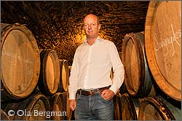The white Corton is a result of the previous generation’s wish to have a white wine. At the time Domaine Chandon de Briailles was 100 per cent red, so when part of Bressandes was up for replanting they decided to plant some chardonnay.
– Since it is chardonnay you cannot put Corton Bressandes on the label, just Corton, says François de Nicolay. As a wine it has nothing to do with the Corton-Charlemagne. The white Corton is a very generous, big wine, even when it’s young. You can keep it for ages. I always say it’s a gastronomical wine. It’s less intellectual than the Corton-Charlemagne.
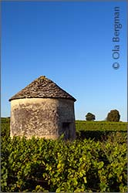Domaine Chandon de Briailles went biodynamic in 2005. In 2008 they applied for certification and in 2011 they were granted it by Ecocert and Demeter. But already in 1988 the domaine stopped using herbicides and started moving towards lutte raisonnée.
– Since 2005 we can see that the vines are growing differently, says François de Nicolay. The leaves seems more alive and healthy. When you taste the grapes at harvest they are better balanced with the acidity. The aromas are better.
The domaine uses whole clusters, but depending on the appellation and how healthy the grapes are the amount varies from 30 per cent up to 80 per cent.
– To put it simple, when the vintage is hot and gives high ripeness, like 2009 for example, we use more whole clusters. When the vintage is less ripe such as 2008 or 2011, we use less.
The use of new oak is quite modest at Domaine Chandon de Briailles, both for the reds and the whites. It is about five per cent for the premier crus and about ten per cent for the grand crus. But as for the use of whole clusters much depends on the wine and the vintage.
© 2013 Ola Bergman

